Annexure-I

I. FTTH Plan:

With declining revenue from the voice services, the focus of the carriers is moving towards increasing revenue from the data services and video services. Deploying the right and future proof access technology shall also be one of the important factor for the success and profitability of the Telecom operator. The growing popularity of the Internet is the key driver behind the development of new access methods which would enable a customer to experience a true broadband. Amongst various technologies, the access methods based on the optical fiber are getting more and more attention as they offer the ultimate solution in delivering different services to the customers’ premises.

Carrier success in delivering the ‘triple-play’ of voice, video, and data is not only dependent upon the proper choice of service and content partners but also on the right network infrastructure. This network infrastructure must be capable of evolving as business and consumer needs change, as new services and applications are introduced into the marketplace, and as bandwidth needs grow. We are on the cusp of the next great evolution in subscriber connectivity – from dial, to low-speed broadband delivered over copper or Hybrid Fibre Coaxial (HFC, sometimes referred to as ‘midband’, or ‘advanced services’ and ‘first-generation broadband’ by the US Federal Communications Commission), and now to fiber, or ‘advanced broadband’, offering true broadband connectivity capable of supporting HDTV, multiple lines of voice, and Internet access bursting to 10 Mbps and beyond. Only Fibre networks provide all the advantages desired by a Telecom Carrier. Accordingly, the PON technologies based on this Fibre network infrastructure, which drive the high bandwidth upto the customer, are proposed to support the advanced broadband or the Next Generation Play Network (NGPN).

This Next Generation Play Network (NGPN) is being driven by the factors such as Competition, Customer Demand and the Government Policy. Profit making in rolling out the high end and new services is also one of the factors driving these technologies. The proposed roadmap is as given below.

Phase-I ( 2008-09)

Originally Overlay Access Network is planned in 98 cities where the numbers of DELs are more than 3 Lakhs. Hence in the phase-I Ethernet in the First Mile ( EFM ) using the FTTB, FTTH is proposed to be deployed. FTTX systems are devised as either point to point Optical systems or Point to Multipoint Fibre systems ( also known as Passive Optical Networks-PON. 7,00,000 customers are targeted in the first year. The numbers of customers targeted in each of these 98 cities are tabulated below1.5 Lakhs customers are planned in 73 cities with GE-PON and 5.5 Lakhs customers in 25 cities with G-PON and both are also referred to as the Ethernet To The Home (ETTH) technologies often.

Based on successful implementation of the project and also based on the feedback from the field units, we may consolidate one PON technology and implement the same. In case both the technologies suit the BSNL network, we may continue with both the technologies in further PON planning.

Phase-II ( 2009-10)

The second phase of G-PON/GE-PON deployment can be extended to other cities also having OAN cable already laid as per the OAN target. Phase-II FTTH plan shall target 7,00,000 customers to be extended with fast Ethernet/ Gigabit Ethernet service to their buildings on Fibre.

Phase-III ( 2010-11)

This year OAN project is proposed to be commenced in 198 cities where NIB-2.2 is being executed. Therefore the third phase of Ethernet To The Home ( ETTH ) can be taken up in all these 198 cities. Sufficient fibre infrastructure shall be in place by then in all these cities for commencing the ETTH service in all these cities the broadband FTTH customers to be targeted. Thus the total target of the FTTH deployment in 2010-11 shall be approximately 7, 50,000.

The FTTH plan proposal is made for commercial and technical aspects of the Fibre To The Home project. The total customer base on FTTH upto March 2011 shall be 2 Millions.

II. FTTH Technical proposal:

The detailed design aspects, architecture and service roll-out plan of the proposed Fibre To The Home plan is as given below.

In a standard passive optical network ( PON ), the Optical Line Terminal ( OLT ) resides in the central office or headend. It transmits an optical signal to a splitter, from which the signal is distributed to multiple customers directly or via another splitter. Optical-Network Terminals (ONT) terminate the signal at the customer premises or, in the case of a fiber to the curb architecture, at a remote hub. PON technology allows the service provider to share the fiber cost of running fiber from the CO to the premises among many users—usually up to 32 locations. PON deployments define a maximum distance, typically 20 km, between the OLT and the ONU (ONT). As shown in Figure 1, the fiber run from the CO is brought to a centralized distribution point, and then extends from this fiber to each customer location. The extension of the fiber is done via passive optic splitters or filters at the distribution point, which guide the laser light on the fiber to their appropriate locations.

PONs do not require any power in the outside plant to power the filters or splitters, thereby lowering the overall operational cost and complexity. And because the single fiber either in a ring or tree technology is shared, this "high-cost" capital deployment of fiber for several kilometers is lower than if the carrier were to deploy individual fibers to each location.

Passive Optical Splitters are used to split the fibre/bandwidth and share among many customers. The first challenge is the Pre-planning the exact location of the splitters in relation to the OLT so that optimum customers are loaded on the FTTH system.

a. Basic FTTH arcitecture

The basic FTTH architecture is shown in Fig 1 below. Fig.2 shows the PON configuration in details.

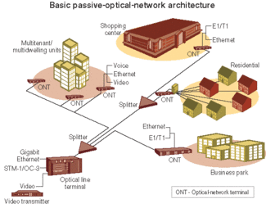

Fig-1

Fig.2

EPON is based on the Ethernet in the First Mile standard of IEEE while GPON is based on the G.984.x series standard of ITU-T. EPON is also called now as Gigabit Ethernet PON ( GE-PON). In further notings EPON and GE-PON references indicate one technology only.

b. Core Network Interfacing

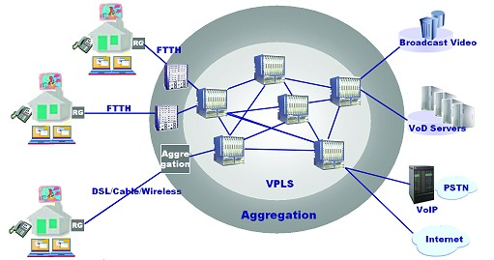

Fig-2

The proposed core networking of FTTH shown in Fig2 above. The FTTH customers are brought to the exchanges in different cities and aggregation is done. The aggregated FTTH city network is interfaced with the MPLS backbone of NIB. At various Gateway locations, Internet, PSTN, VOD servers and Broadcast servers can be connected to the MPLS network. Thus various services can be extended to the FTTH customers.

III. Fibre to the Home (FTTH) Out Door Network (ODN) Planning Guidelines.

BSNL has planned 2 million FTTH network based on Gigabit Optical Passive Network (GPON) and Gigabit Ethernet Passive Optical Network (GEPON) upto 2010. The broadband, voice, data & video etc services will run on this network. All these services clubbed into a brand name Next Generation Play Network( NGPN). These services will be rolled out in phase manner in three phases. In its first phase BSNL CO has planned to procure 5 lakhs GPON customers and 1.5 lakhs GEPON customers. A-Grade cities are planned for GPON and B-Grade cities are for GEPON. The GEPON and GPON technologies based cities planned for first phase planned are listed in the annexure-1.

The FTTH network constitutes indoor equipments and outdoor network (ODN) and customer premises equipments. The network architecture is figured below. In spite of the GPON/GEPON equipments, fibers are the most important constituent of these network. The planning of the fibre network from FDF/ODF/FDMS to the splitter is very important to successfully role out and easy maintains the ODN.
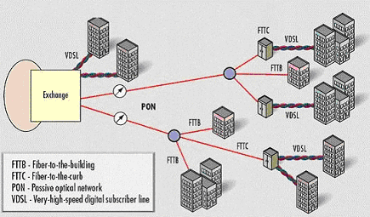
Fig-1. General Schematic of Passive Optical Fibre Network.

The services of GPON are fibre protected and in the ring fashion from the first splitter to the GPON chassis. However, the GEPON services are unprotected as GEPON equipments do not provide the redundancy. Each GPON chassis support maximum 320 fibre protected customers. While GEPON chassis supports maximum 640 unprotected customers. GPON chassis can support 192 protected additional customers by upgrading with 12 redundant PON ports in each chassis.

The ODN constitutes of FDF /ODF/FDMS to high count ribbon cables (96F / 288F), OAN termination of 24F/12F/6F (OF) first mill access network cable and termination of these fibres in the building / MDU. The services on FTTH can be extended up to 60 Km logical reach and 20 Km physical reach from the GPON / GEPON chassis.

The GPON / GEPON equipments, FDMS/ODF/FDF patch cord, pig tails and splitters are to be supplied from centrally procurement. The outdoor network shall be planned by Project Circles in consent to the respective territorial circle. Project circle may plan the ODN in consultation with respective territorial circles.

The fibre planning for GPON and GEPON are different and same described below. The planning and installation of GPON / GEPON based systems will be carried out by the Project Circles. The project circles will carry out the Out Door Network (ODN) planning by High Count (Ribbon Type Cables) planning, fibers planning, laying of leading OF cables, its terminations in Termination Boxes, installation of splitters in concurrence with respective territorial circle. The territorial circles will generate the demand and install the H-ONT, Maintain the Network, create the subscribers, subscriber management systems etc.

a) Out Door Network (ODN) planning and fibre planning for GPON.

The Overlay Access Network ( OAN) to be planned in all broadband cities by deploying high count OF cables. Optical fibre is to be terminated in all the premises of the commercially important customers and potential customers and ISPs by extending from the nearest manhole / fibre access point for providing the any time bandwidth to the customer.
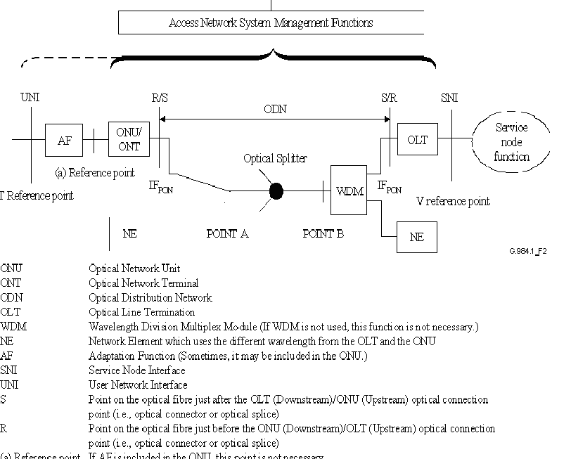

Figure-2: Configuration for a Passive Optical Network showing ODN parts

The minimum fibre count is to be deployed in those cities should be 96F or 288 F and above in the main routes and 24 F/12F cables for leading into the buildings. The leading fibres shall be terminated in fibre termination box (FTB). The FTBs shall be accordingly to 24F / 12F capacity.

b) 2:32 split architecture.

It is prefer to have one splitter in the premises of the customer / building / locality. The two leading fibre from the 24F/ 12 F cables say fibre 1 and 2 shall be the input to the 2:32 splitter. These two fibres shall be joint in the two sides of the main route OAN fibre no. 1. The other side of the main route fibre will form a ring through different physical rank and will be terminated on port 2 ( redundancy PON port). Similar fashion shall be adopted for other splitters on the same leading fibre for next building.

Fig.3: Schematic showing single or multi-stage splitting

c) Cascade split architecture in GPON:

Since the number of customers are lesser in the beginning and distributed across the city, cascade splitters can be deployed to cover more area. As a general design parameter, the number of splits proposed can be only two. The splitters may be used in any of the following combinations such as 2:4 & 1:16, 2:4 & 4X (1:8), 2:8 & 1:4 etc. In all such situations, the two fibres of leading cable will spliced to the two sides of single fibre in the main route OAN cable. Thre splitter out port fibres will be terminated back to the leading fibre say no. 3 to 5 which will be used at next location splitter in the same leading fibre route and one will be used at the same location for further split into 1:8 for 8 Customers. Hence, in case of fibre cut in the main rout at any side of the fibre, the services will be uninterrupted however fibre cut occurs in the leading cable, services on affected splitters shall be interrupted. In any case if the fibre cut occurs in the leading fibre (12F/24F) services will be fully interrupted till restoration of the leading OF Cables.
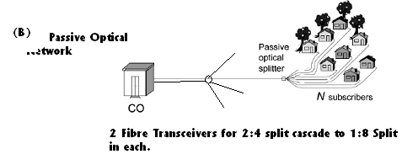

d) GEPON based Next Generation Play Networks Planning:

The GEPON networks do not support the redundancy. Accordingly only Single Fibre and single input splitters are planned. There are 20 PON Ports per GEPON Chassis and each chassis is capable to cater 32X20=640 customers. There are only 1:2, 1:4, 1:8, 1:16 and 1:32 split ratio splitters planned. 1:32 split architecture shall be used in the highly dense locations and multistoried buildings. In case of customers are lesser in the beginning and distributed across the city, cascade splitters can be deployed to cover more areas. The single fibre will be directly connected to the splitters. Splitters may be planned directly or in cascade. In case of cascade, split loss shall be taken care and it shall be within the limit of 10*log(32) db. Some quantities of 2:4 splitters are also planned. These splitters will be used in the Central Office (CO). In case of very important customers are to be served with GEPON services and in case of fibre cut in one side, manually connection of the GEPON Port can be carried out to the ring fibre and services can be restored.

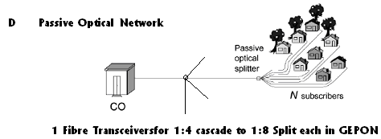

e) Main route (High Count Fibre) planning:

The minimum fibre count to be deployed in OAN projected cities shall be 96F or 288 F. There is a manhole at nearly 200M distance gap in the each route. The leading fibre can be spliced to high count ribbon fibre cables suitably at the nearest manhole. The High Count Ribbon Type fibre cables come in a bundle of multiples of 12F. The High Count fibre ribbon cable shall be planned in such a way that there shall be a ring from the different physical path. Since each GPON chassis having 10 PON ports as active and 10 PON ports in redundancy. So only one set of 12Fibre of High Count fibre shall be used for 10 PON ports termination. Other 10 redundant ports shall be terminated on the first set of other side of the ring of the High Count fibre cable.

In each case an active 10 PON fibres or redundant 10 PON fibres shall be first set of 12F, in High Count Fibre cable. This will ease in fibre identification and maintenance. The shortest physical distance shall be followed to cater the first splitter.

f) Numbering schemes:

It will be easy to identify the fibre and fibre management by following the uniform numbering scheme for all network element on the OPN.

g) GPON chassis numbering code:

STD code + Area code + GP +two digits (00-99)

h) GEPON chassis numbering code:

STD code + Area code + GE + two digits (00-99)

As nationalized monitoring and service provisioning will be executed from the NMS of NIB-II, it will be easy to identify the GPON / GEPON chassis.

i) OAN fibre numbering code:

FD MS + two digit (FDMS fibre position) + (00-99) + (00-12)

IV Proposed Services on FTTH network

The first and foremost service proposed in the deployment of these PON technologies is to roll out the Next Generation Play Network (NGPN). Ethernet Private Leased Lines ( EPL), Ethernet Private LAN service ( EP-LAN) to the customers requiring the high bandwidth. Today Ethernet is the most popular medium used by the most of the customers in their Local Area Networks ( LAN). In addition Ethernet, being the most common and interoperable protocol, is being used extensively in all the computer – communication products. Hence Ethernet access service shall be the one of the popular service in the current days of computer communication. The regular TDM leased lines give away to this Ethernet access service.

EPLs are the point to point leased lines extending the Ethernet transparently and securely between the two customer sites. The Ethernet Private LAN service can be offered in the Point to Multipoint method ( Hub-Spoke ) or Multipoint to Multipoint ( Local Area Network ) method. EPLAN can be offered to customer as Wide Area Network ( WAN ) service. Apart from bigger bandwidth requirements, some of the high end customers require carrier class reliability upto their premises. These PON technologies shall be one of the ultimate technologies that delivers both high bandwidth and high reliability. The fibre redundancy upto the customer premises ensures this reliability.
It shall be easier to sign the Service Level Agreements ( SLA) with the customers using the PON technologies. These PON technologies shall permit management of the customer premises equipment ( Optical Network Terminals – ONTs ). End to end provisioning feature on PONs enable the service provider to dynamically manage the customer needs.

The second important service proposed to offered to customers is Next Generation Broadband Service. This PON technology can also be used to deliver Broadband service to the customers in the Technically Non Feasible ( TNF ) areas. Normally the 2 Mb/s ADSL broadband connection works upto 4Kms. The 2Mb/s and other high speed Broadband connections needs to deploy either VDSL or alternate medium connection such as wireless. Higher bandwidths for broadband connections can be delivered to the customers as remote as 20 Kms from the Exchange premises with the PON technologies. PON technology allows the service provider to share the fiber cost of running fiber from the CO to the premises among many users—usually up to 32 locations. Since multiple customers use the single fibre infrastructure, the cost of the service roll-out shall be lower than for the fibre provisioning for the individual customer. Thus customers can be offered the broadband service in the entire operational area of BSNL network.

The third service that can be proposed is the voice service ( TDM or IP), i.e. extension of PSTN lines to the customers. In GPON, this service can be extended using the 64 Kb/s TDM lines from exchange to customer. Alternately to cover a group of customers, we may use V 5.2 interface to extend the voice service to the customer premises. In case of GE-PON the voice service can be extended to the using Voice Over Internet Protocol ( VOIP.

From the BSNL network point of view GPON, being the TDM based technology, shall integrate into the existing switching network. While the VOIP feature in the GE-PON provides easy migration path to the Next Generation Network ( NGN ) of the BSNL. Since TDM switches and the NGN are to coexist for upto 2015 as per the NGN vision plan both GPON and GE-PON are the most suitable PON technologies for BSNL.

The video service ( Radio Frequency - RF or IP), which is one of the triple play services, is the fourth service proposed to be extended to the customer. GE-PON offer 1.25 Gb/s capable Gigabit connectivity upto the customer premises.

Both GPON and GE-PON can also roll-out broadcast Cable TV services using the third wavelength at 1550 nm using RF-video. This third wavelength

a. GPON:

GPON supports two methods of encapsulation: the ATM and GPON encapsulation method (GEM). The ATM method is an evolution of existing APON/BPON standards, and all voice, video, and data traffic is encapsulated at the customer premises for transport back to the CO. With GEM, all traffic is mapped across the GPON network using a variant of SONET/SDH generic framing procedure (GFP). GEM supports a native transport of voice, video, and data without an added ATM or IP encapsulation layer. GPONs support downstream rates as high as 2.5 Gbits/sec and upstream rates from 155 Mbits/sec to 2.5 Gbits/sec. BSNL is procuring the GPON that will support downstream rate 2.5Gbps and upstream 1.25 Gbps.

b. EPON:

As with standard Gigabit Ethernet, EPON has a nominal bit rate of 1250 Mbps, using 8B/10B encoding. It is defined as a single fiber network using Wavelength Division Multiplexing (WDM) operating at a wavelength of 1490 nm downstream and 1310 nm upstream. This leaves the 1550 nm window open for other services, such as analog video or private WDM circuits. EPON Physical media Dependent (PMD) choices will include short reach optics with a range of 10 km and a 1:32 split ratio, and long reach optics with a range of 20 km and a 1:32 split ratio. Ideally, this will allow for interoperability and intermixing of different PMD types enabling a wide range of split ratios and distances. Low-cost Gigabit EPON transceivers using Distributed Feedback (DFB) or Fabry-Perot lasers and high sensitivity APD and PIN detectors are available. This is important, as optical transceivers have historically been the highest cost component in a PON network.

V. Fibre Infrastructure

As per the transmission media guidelines announced in March 2005 and March 2008 , Overlay Access Network is to be planned in all the District Head Quarters. High Count Fibres ( 96F/288F ), Multiple PLB pipes and FDMS are deployed in the Overlay Access Network. OAN aims at creating Optical fibre infrastructure for supporting all the network elements (RSU/RLC/DLC/GSM/WLL/LMDS/Leased lines/NIB) and the customers. It may be observed that all the network elements being deployed in the network including the routers, LAN Switches require the Dark fibre.

1. Apart from this NIB 2.2 project is being executed in 248 cities. This year the broadband group has proposed to increase the number of cities to 315. Dark fibre is required for the DSLAMs to the Ethernet Switches in all these cities. Number of DSLAMs shall increase over the years also.

2. GSM network is also growing with the execution of Phase-V+ and with the 60,000 sites are planned by the CMTS group for this project.

3. Broadband DLCs are also planned. These B-DLCs also require the Optical fibre cable.

4. Fibre needs to be provided for very important customers also for providing leased lines.

5. Apart from this all the new evolving technologies and customer demands, and new services require high speed connectivity to the customer. Thus requirement Optical Fibre in the Exchange Area becomes the important for the Telecom Carrier.

In general the Telecom Service Providers are now focusing more on establishing their backbone network. Very few are planning the Access Network. Thus for increasing the fibre availability and for developing a strong Optical Access in all the cities, especially where NIB / Broadband projects are being deployed, creating a Fibre infrastructure becomes essential.

World wide the deployment of fibre in the access area is becoming the primary target for all the carriers. World leaders in the broadband deployment such as Korea, Japan, US and Europe have already switched towards FTTH which is becoming cheaper. The broadband service on FTTH is offered at the same rate as that of the DSL modems. With their experience on using Fibre, FTTH ( FTTX) using PON technologies are the suitable alternative in the near future for providing the broadband services.

The project circles are executing the Fibre To The Curb ( FTTC ) project alternately known as Overlay Access Network. As soon as the customer requirement is available the fibre laying from the nearest Manhole ( Fibre Access Point ) to the customer is completed and the service provisioning is done quickly.

VI. Equipment design aspects:

a. OLTs

AT the central office side OLTs that can be subrack /chassis mounted rack type are preferable. OLTs are collocated with the exchange. These equipments work at 48V DC power supply.

b. ONTs

At the customer end the ONTs shall be pizza box type. The power input for ONT is 230V AC type with power back for 4 Hrs. Indoor type ONTs are supplied.

c. PON Splitters

The Optical power budget is an important consideration in PON design because it determines the number of ONUs (ONTs) can be supported, as well as the maximum distance between the OLT and ONUs (ONTs). There is a tradeoff between the number of ONUs (ONTs) and the distance limit of the PON because optical losses increase with both split count and fiber length.

VII. Management and service provisioning in PONs:

The management capabilities of the equipment needs to explained. Both the OLTs and ONUs must be manageable locally as well as from a remote site. The OLTs will have a Local Craft terminal with every OLT rack ordered. One Element Manager System is also there for managing the whole network of a particular technology product.. EMS shall be capable of managing all the OLTs in the same city and also the OLTs of same PON technology in the remote cities using the Data Communication Network (DCN).

VIII. Annexure: City Planned for GPON/ GEPON Ports:
Sl No | Region | Circle | GEPON Cities | customers | GEPON | GPON | Customers | CPON
 |  |  |  | Proposed | Chassis | Cities | Proposed | Chassis
1 | West | Chhattisgarh | Raigarh | 638 | 2 | Raipur | 15202 | 48
2 | West | Gujarat | Anand | 634 | 2 | Ahmadabad | 19362 | 61
3 | West | Gujarat | Baroda | 3590 | 11 | Pune | 9196 | 29
4 | West | Gujarat | Mehsana | 1157 | 4
5 | West | Gujarat | Rajkot | 500 | 2
6 | West | Gujarat | Surat | 2555 | 8
7 | West | Maharashtra | Aurangabad | 2180 | 7 | Nagpur | 44470 | 139
8 | West | Maharashtra | Dhulia | 1194 | 4 | Indore | 6621 | 21
9 | West | Maharashtra | Goa | 4057 | 13
10 | West | Maharashtra | Kalyan | 3727 | 12
11 | West | Maharashtra | Kolhapur | 2924 | 9
12 | West | Maharashtra | Nasik | 2451 | 8
13 | West | Maharashtra | Nanded | 785 | 2
14 | West | Madhya Pradesh | Bhopal | 4169 | 13
15 | West | Madhya Pradesh | Gwalior | 1216 | 4
16 | West | Madhya Pradesh | Jabalpur | 1020 | 3
17 | West | Madhya Pradesh | Sagar | 763 | 2
18 | West | Madhya Pradesh | Satana | 200 | 1
19 | South | Andhra Pradesh | Adilabad | 216 | 1 | Hydrabad | 30516 | 95
20 | South | Andhra Pradesh | Anantpur | 485 | 2 | Vijayawada | 6018 | 19
21 | South | Andhra Pradesh | Eluru | 388 | 1
22 | South | Andhra Pradesh | Nellore | 1624 | 5
23 | South | Andhra Pradesh | Rajahmundary | 445 | 1
24 | South | Andhra Pradesh | Tirupathi | 413 | 1
25 | South | Andhra Pradesh | Visakhapatnam | 2557 | 8
26 | South | Andhra Pradesh | Warangal | 657 | 2
27 | South | Kerala | Kalikat | 3810 | 12 | Ernakulam | 16410 | 51
28 | South | Kerala | Palghat | 2784 | 9
29 | South | Kerala | Triture | 5732 | 18
30 | South | Kerala | Trivandrum | 1663 | 5
31 | South | Karnataka | Belgaum | 499 | 2 | Banglore R | 19838 | 62
32 | South | Karnataka | Hubli& Dharwad | 1517 | 5 | Banglore TD | 26301 | 82
33 | South | Karnataka | Karwar | 188 | 1 | Manglore | 16111 | 50
34 | South | Karnataka | Mysore | 4557 | 14 | Coimbatore | 12436 | 39
35 | South | Karnataka | Raichur | 245 | 1
36 | South | Tamilnadu | Madurai | 869 | 3 | Chennai TD | 36677 | 115
37 | South | Tamilnadu | Pondicherry | 564 | 2 | Kancheepuram | 956 | 3
38 | South | Tamilnadu | Salem | 513 | 2 | Tiruvallur | 589 | 2
39 | South | Tamilnadu | Trichy | 1054 | 3
40 | South | Tamilnadu | Vellore | 480 | 2
41 | South | Chennai-TD |  |  |  | Chennai TD | 36677 | 115
42 | North | UP(W) | Agra | 6780 | 21 | Noida | 10468 | 33
43 | North | UP(W) | Ghaziabad | 5967 | 19 | Greater NOIDA | 5150 | 16
44 | North | UP(W) | Murabad | 398 | 1
45 | North | Uttaranchal | Almora | 598 | 2
46 | North | Uttaranchal | Dehradoon | 2359 | 7
47 | North | UP (E) | Allahabd | 5602 | 18 | Lucknow | 39600 | 124
48 | North | UP (E) | Gorakhpur | 3339 | 10
49 | North | UP (E) | Jhansi | 998 | 3
50 | North | UP (E) | Kanpur | 3982 | 12
51 | North | UP (E) | Varanasi | 6803 | 21
52 | North | Haryana | Amballa | 2251 | 7 | Gurgaon | 30544 | 95
53 | North | Haryana | Faridabad | 5602 | 18
54 | North | Rajasthan | Ajmer | 1408 | 4 | Jaipur | 35378 | 111
55 | North | Rajasthan | Alwar&Bhiwadi | 3734 | 12
56 | North | Rajasthan | Jodhpur | 2188 | 7
57 | North | Rajasthan | Kota | 1201 | 4
58 | North | Rajasthan | Udaipur | 975 | 3
59 | North | Punjab | Amritsar | 7017 | 22 | Chandigarh | 9436 | 29
60 | North | Punjab | Ferozpore | 1907 | 6 | Jalandhar | 41094 | 128
61 | North | Punjab | Ludhiana | 9228 | 29
62 | North | Punjab | Patiala | 3408 | 11
63 | North | Punjab | Sangrur | 2335 | 7
64 | North | Himachal Pradesh | Simla | 500 | 2
65 | North | Jammu & Kashmr | Jammu | 625 | 2
66 | East | Kol-TD |  |  |  | Kolkata | 40580 | 127
67 | East | Orissa | Rourkele | 435 | 1 | Bhubeneshwar | 7504 | 23
68 | East | Orissa | Sambalpur | 624 | 2
69 | East | West Bengal | Durgapur | 1418 | 4
70 | East | West Bengal | Siliguri | 1125 | 4
71 | East | Bihar |  |  |  | Patna | 17419 | 54
72 | East | Jharkhand | Dhanbad | 250 | 1 | Ranchi | 12506 | 39
73 | East | Jharkhand | Jamshedpur | 413 | 1
74 | East | Andaman& Nicobar | Port Blare | 625 | 2
75 | NE | Assam | NE | 0 | 0 | Gowahati | 2943 | 9
76 | NE | North East-I | NE | 625 | 2
77 | NE | North East-II | NE | 625 | 2
 |  | Total |  | 150365 | 474 |  | 550002 | 1719

